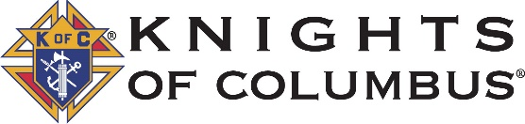
Michigan State District Meeting Agenda – Summer 2022
Pre-meeting:
- Registration
- Check council prework (Have forms on-hand for any that are not done (185, 365, 2629, MI-19 & Council Directory)
- Dinner (Pray before dinner is served)

Meeting:
- Opening Prayer, Salute to Country, Welcome, Introductions
- Star Council Requirements
- Michigan Achievement Award
- Membership Growth
  - Exemplifications – Review District Exemplifications & Schedule on the State Website
  - Recruiting – MI-19 or CAT status, Drive Weekend & Best Practice checklist
  - Goals – Quotas, +1 from last year & active round tables
- Faith in Action
  - Directors
  - Plans
  - Form 10784
- Member Experience
  - Engagement review (Onboarding, Communicating, Interacting, Formation, Recommitment)
  - Member information maintenance
  - Retention Plans
- Council Training
  - Youth Protection
  - State Website
  - Council Officer Training
- Agency Report
  - Fraternal Benefit Nights
  - Field Agent Engagement
- Dignitary Remarks
- Closing Prayer
Post-meeting: Serve refreshments & snacks and allow time for Q&A and fraternity

